1. Write a Python code to read and write a color/gray image.

import cv2

def read_and_write_image(input_path, output_path, is_color=True):

    # Read the image

    if is_color:

        image = cv2.imread(input_path, cv2.IMREAD_COLOR)

    else:

        image = cv2.imread(input_path, cv2.IMREAD_GRAYSCALE)

    # Check if the image was successfully read

    if image is None:

        print(f"Failed to read the image from {input_path}")

        return

    # Write the image to the output path

    success = cv2.imwrite(output_path, image)

    if success:

        print(f"Image successfully written to {output_path}")

    else:

        print(f"Failed to write the image to {output_path}")

input_image_path = 'apple.jpeg'

output_image_path_color = 'output.jpg'

read_and_write_image(input_image_path, output_image_path_color, is_color=True)

read_and_write_image(input_image_path,output_image_path_color, is_color=False)

Output:

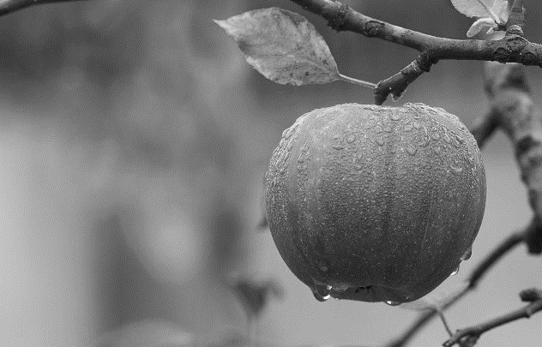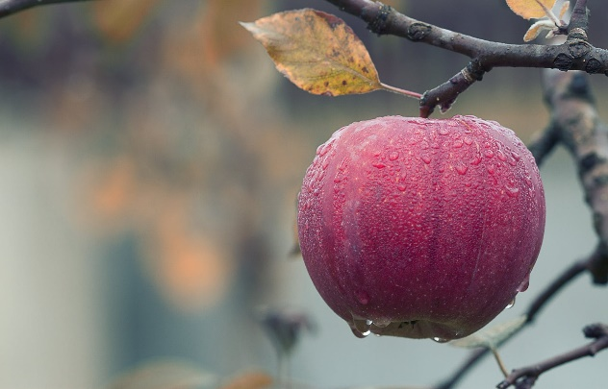Color Gray

1. Write a Python code for bit plane slicing of an image.

import cv2

import numpy as np

def bit_plane_slicing(image_path):

    image = cv2.imread(image_path, cv2.IMREAD_GRAYSCALE)

    if image is None:

        print(f"Failed to read the image from {image_path}")

        return

    rows, cols = image.shape

    bit_planes = []

    # Extract each bit plane

    for i in range(8):

        bit_plane = np.zeros((rows, cols), dtype=np.uint8)

        bit_plane[:, :] = (image[:, :] & (1 << i)) >> i

        bit_plane *= 255

        bit_planes.append(bit_plane)

        output_path = f'bit_plane_{i}.png'

        cv2.imwrite(output_path, bit_plane)

        print(f"Bit plane {i} saved as {output_path}")

    return bit_planes

# Example usage

input_image_path = 'apple.jpeg'

bit_planes = bit_plane_slicing(input_image_path)

for i, bit_plane in enumerate(bit_planes):

    cv2.imshow(f'Bit Plane {i}', bit_plane)

cv2.waitKey(0)

cv2.destroyAllWindows()

Output:

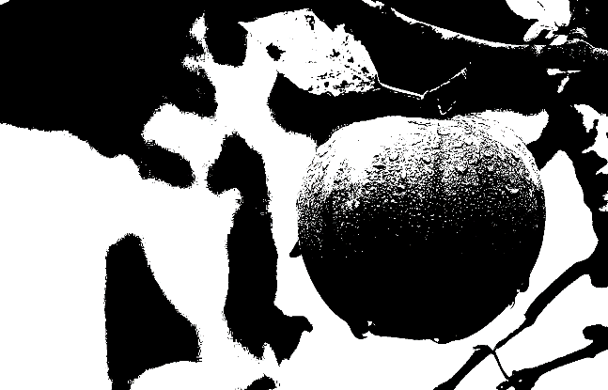

1. Write a Python code for intensity level slicing of an image.

import cv2

import numpy as np

def intensity_level_slicing(image_path, lower_bound, upper_bound, high_intensity=255, low_intensity=0):

    image = cv2.imread(image_path, cv2.IMREAD_GRAYSCALE)

    if image is None:

        print(f"Failed to read the image from {image_path}")

        return None

    sliced_image = np.zeros_like(image)

    sliced_image[(image >= lower_bound) & (image <= upper_bound)] = high_intensity

    sliced_image[(image < lower_bound) | (image > upper_bound)] = low_intensity

    return sliced_image

input_image_path = 'apple.jpeg'

output_image_path = 'sliced_image.jpg'

lower_bound = 100

upper_bound = 200

sliced_image = intensity_level_slicing(input_image_path, lower_bound, upper_bound)

if sliced_image is not None:

    cv2.imwrite(output_image_path, sliced_image)

    print(f"Intensity level sliced image saved as {output_image_path}")

    input_image = cv2.imread(input_image_path, cv2.IMREAD_GRAYSCALE)

    cv2.imshow('Original Image', input_image)

    cv2.imshow('Intensity Level Sliced Image', sliced_image)

    cv2.waitKey(0)

    cv2.destroyAllWindows()

Output:

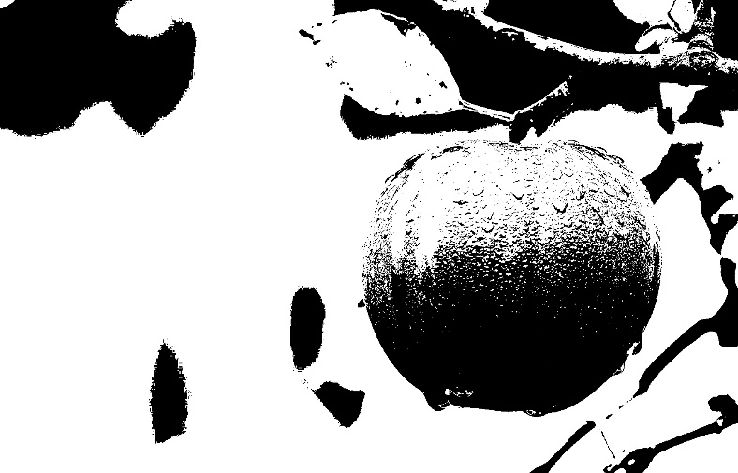

1. Write a Python code for contrast stretching of an image.

import cv2

import numpy as np

import matplotlib.pyplot as plt

def contrast_stretching(image):

min_val = np.min(image)

max_val = np.max(image)

stretched_image =(image-min_val)/(max_val-min_val)*255).astype(np.uint8)

return stretched_image

def plot_histogram(image, title):

hist, bins = np.histogram(image.flatten(), 256, [0, 256])

plt.figure()

plt.title(title)

plt.xlabel("Pixel Value")

plt.ylabel("Frequency")

plt.plot(hist)

plt.xlim([0, 256])

plt.show()

input_image_path = 'forest.png'

output_image_path = 'path/to/your/output/contrast_stretched_image.jpg'

image = cv2.imread(input_image_path, cv2.IMREAD_GRAYSCALE)

if image is None:

print(f"Failed to read the image from {input_image_path}")

else:

plot_histogram(image, "Histogram of Original Image")

stretched_image = contrast_stretching(image)

plot_histogram(stretched_image, "Histogram of Contrast-Stretched Image")

cv2.imwrite(output_image_path, stretched_image)

print(f"Contrast-stretched image saved as {output_image_path}")

cv2.imshow('Original Image', image)

cv2.imshow('Contrast-Stretched Image', stretched_image)

cv2.waitKey(0)

cv2.destroyAllWindows()

Output:

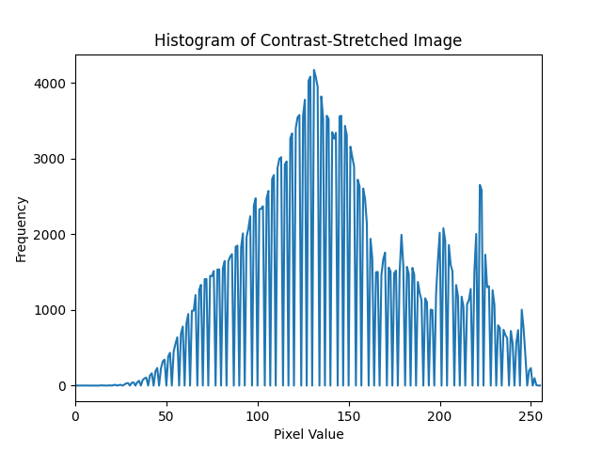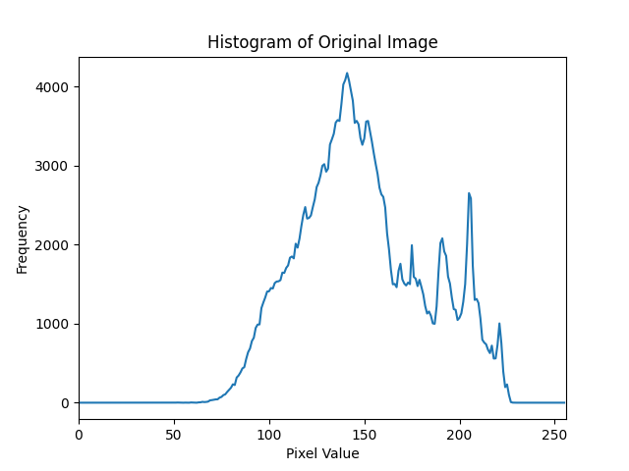

1. Write a Python code to generate a negative image from a gray image.

import cv2

import numpy as np

def generate_negative_image(image_path, output_path):

    # Read the image in grayscale

    image = cv2.imread(image_path, cv2.IMREAD_GRAYSCALE)

    if image is None:

        print(f"Failed to read the image from {image_path}")

        return

    negative_image = 255 - image

    cv2.imwrite(output_path, negative_image)

    print(f"Negative image saved as {output_path}")

    cv2.imshow('Original Image', image)

    cv2.imshow('Negative Image', negative_image)

    cv2.waitKey(0)

    cv2.destroyAllWindows()

# Example usage

input_image_path = 'apple_gray.jpeg'

output_image_path = 'negative_image.jpg'

generate_negative_image(input_image_path, output_image_path)

Output:

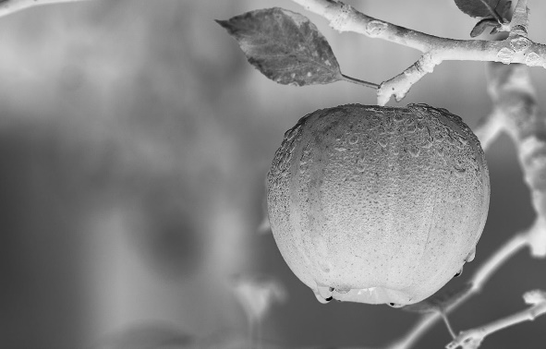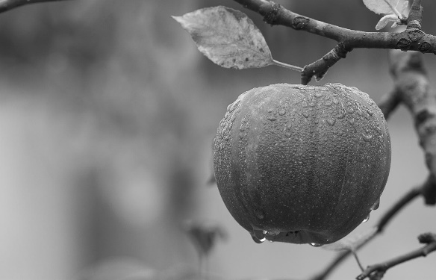Original Negative

1. Write a Python code to represent the histogram of an image.

import cv2

import numpy as np

import matplotlib.pyplot as plt

def plot_histogram(image_path):

    # Read the image in grayscale

    image = cv2.imread(image_path, cv2.IMREAD_GRAYSCALE)

    if image is None:

        print(f"Failed to read the image from {image_path}")

        return

    # Calculate the histogram

    hist, bins = np.histogram(image.flatten(), 256, [0, 256])

    # Plot the histogram

    plt.figure()

    plt.title("Histogram of Grayscale Image")

    plt.xlabel("Pixel Value")

    plt.ylabel("Frequency")

    plt.plot(hist)

    plt.xlim([0, 256])

    plt.show()

# Example usage

input_image_path = 'apple.jpeg'

plot_histogram(input_image_path)

Output:

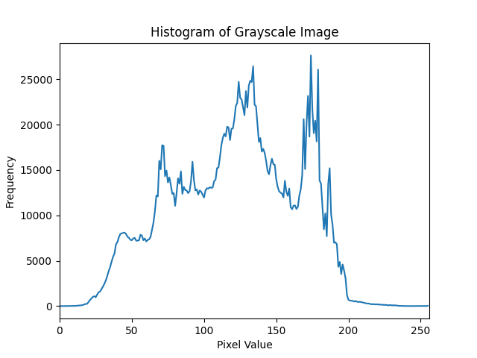

1. Write a Python code for histogram equalization of an image.

import cv2

import numpy as np

import matplotlib.pyplot as plt

def histogram_equalization(image_path, output_path):

    image = cv2.imread(image_path, cv2.IMREAD_GRAYSCALE)

    equalized_image = cv2.equalizeHist(image)

    cv2.imwrite(output_path, equalized_image)

    print(f"Equalized image saved as {output_path}")

    plt.figure(figsize=(12, 6))

    plt.subplot(1, 2, 1)

    plt.hist(image.flatten(), 256, [0, 256], color='r')

    plt.title('Histogram of Original Image')

    plt.xlabel('Pixel Value')

    plt.ylabel('Frequency')

    plt.subplot(1, 2, 2)

    plt.hist(equalized_image.flatten(), 256, [0, 256], color='r')

    plt.title('Histogram of Equalized Image')

    plt.xlabel('Pixel Value')

    plt.ylabel('Frequency')

    plt.show()

    cv2.imshow('Original Image', image)

    cv2.imshow('Equalized Image', equalized_image)

    cv2.waitKey(0)

    cv2.destroyAllWindows()

# Example usage

input_image_path = 'path/to/your/input/apple.jpeg'

output_image_path = 'path/to/your/output/equalized_image.jpg'

histogram_equalization(input_image_path, output_image_path)

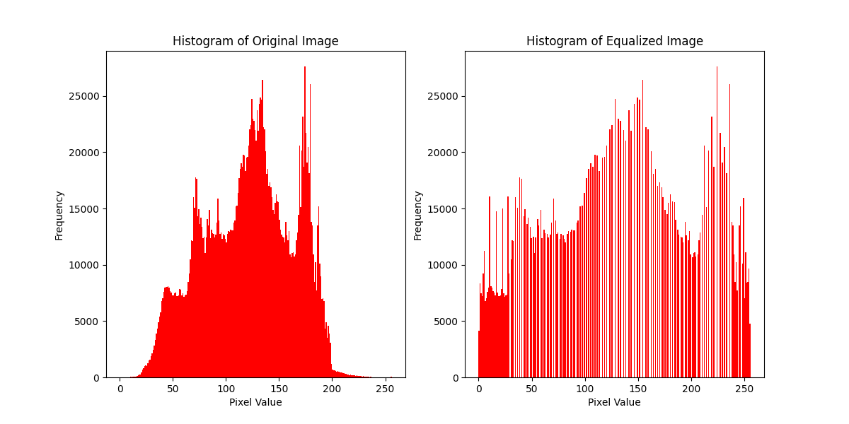Output:

1. Write a Python code to perform the Histogram matching of an image with respect to a reference image.

import cv2

import numpy as np

import matplotlib.pyplot as plt

def plot_histogram(image, title):

    plt.figure()

    plt.title(title)

    plt.xlabel("Pixel Value")

    plt.ylabel("Frequency")

    plt.hist(image.ravel(), bins=256, range=[0, 256], color='r')

    plt.xlim([0, 256])

    plt.show()

def calculate_cdf(hist):

    cdf = hist.cumsum()

    cdf_normalized = cdf * hist.max() / cdf.max()

    return cdf_normalized

def histogram_matching(source, template):

    src_hist, bins = np.histogram(source.flatten(), 256, [0, 256])

    src_cdf = calculate_cdf(src_hist)

    # Compute the histogram and cumulative distribution function (CDF) of the template image

    tmpl_hist, bins = np.histogram(template.flatten(), 256, [0, 256])

    tmpl_cdf = calculate_cdf(tmpl_hist)

    lookup_table = np.zeros(256)

    tmpl_cdf_min = tmpl_cdf[tmpl_hist > 0].min()  # Avoid division by zero

    src_cdf_min = src_cdf[src_hist > 0].min()     # Avoid division by zero

    for src_pixel_val in range(256):

        src_val = src_cdf[src_pixel_val]

        closest_val = np.argmin(np.abs(tmpl_cdf - src_val))

        lookup_table[src_pixel_val] = closest_val

    matched = lookup_table[source]

    return matched

def histogram_matching_cv2(source_image_path, reference_image_path, output_image_path):

    source_image = cv2.imread(source_image_path, cv2.IMREAD_GRAYSCALE)

    reference_image = cv2.imread(reference_image_path, cv2.IMREAD_GRAYSCALE)

    if source_image is None or reference_image is None:

        print(f"Failed to read the source or reference image")

        return

    matched_image = histogram_matching(source_image, reference_image).astype(np.uint8)

    cv2.imwrite(output_image_path, matched_image)

    print(f"Matched image saved as {output_image_path}")

    plot_histogram(source_image, "Histogram of Source Image")

    plot_histogram(reference_image, "Histogram of Reference Image")

    plot_histogram(matched_image, "Histogram of Matched Image")

    cv2.imshow('Source Image', source_image)

    cv2.imshow('Reference Image', reference_image)

    cv2.imshow('Matched Image', matched_image)

    cv2.waitKey(0)

    cv2.destroyAllWindows()

source_image_path = 'apple.jpeg'

reference_image_path = 'forest.png'

output_image_path = 'path/to/your/output/matched_image.jpg'

histogram_matching_cv2(source_image_path, reference_image_path, output_image_path)

Output:

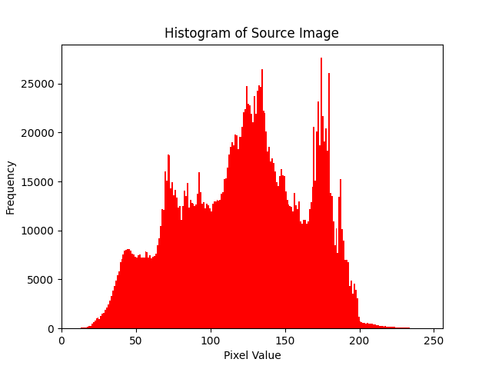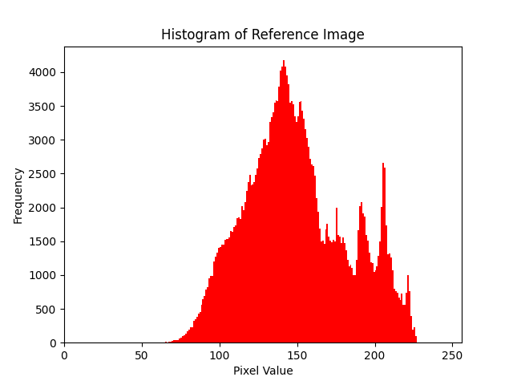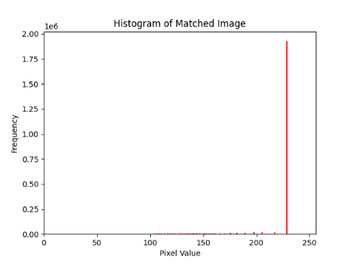Histograms

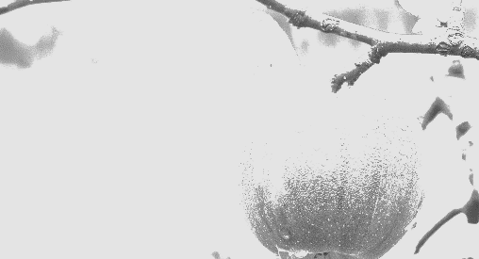Source Images: Reference Image Matched Image

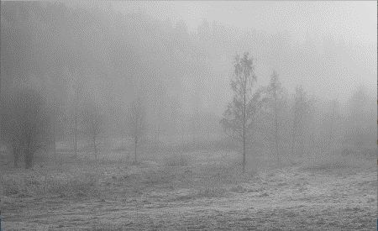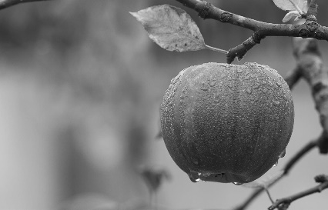

1. Write a Python code for implementing Log transformation of an image.

import cv2

import numpy as np

import matplotlib.pyplot as plt

def log_transformation(image_path, output_path):

    image = cv2.imread(image_path, cv2.IMREAD_GRAYSCALE)

    if image is None:

        print(f"Failed to read the image from {image_path}")

        return

    c = 255 / np.log(1 + np.max(image))

    log_image = c * (np.log(1 + image))

    log_image = np.array(log_image, dtype=np.uint8)

    cv2.imwrite(output_path, log_image)

    print(f"Log transformed image saved as {output_path}")

    plt.figure(figsize=(12, 6))

    plt.subplot(1, 2, 1)

    plt.imshow(image, cmap='gray')

    plt.title('Original Image')

    plt.axis('off')

    plt.subplot(1, 2, 2)

    plt.imshow(log_image, cmap='gray')

    plt.title('Log Transformed Image')

    plt.axis('off')

    plt.show()

    cv2.imshow('Original Image', image)

    cv2.imshow('Log Transformed Image', log_image)

    cv2.waitKey(0)

    cv2.destroyAllWindows()

input_image_path = 'forest.png'

output_image_path = 'log_transformed_image.jpg'

log_transformation(input_image_path, output_image_path)

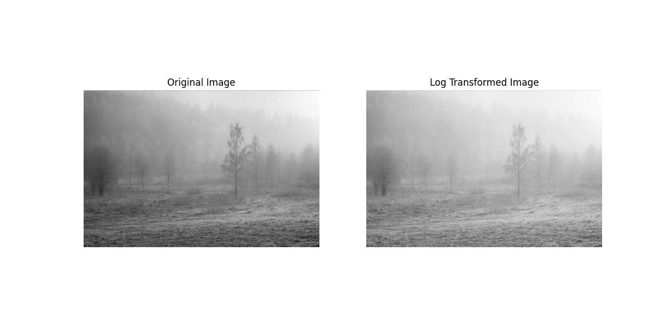Output:

1. Write a Python code for power law transformation of an image.

import cv2

import numpy as np

import matplotlib.pyplot as plt

def power_law_transformation(image_path, output_path, gamma):

    image = cv2.imread(image_path, cv2.IMREAD_GRAYSCALE)

    if image is None:

        print(f"Failed to read the image from {image_path}")

        return

    normalized_image = image / 255.0

    c = 1.0  # Scaling constant

    transformed_image = c * (normalized_image ** gamma)

    transformed_image = np.uint8(transformed_image * 255)

    cv2.imwrite(output_path, transformed_image)

    print(f"Power-law transformed image saved as {output_path}")

    plt.figure(figsize=(12, 6))

    plt.subplot(1, 2, 1)

    plt.imshow(image, cmap='gray')

    plt.title('Original Image')

    plt.axis('off')

    plt.subplot(1, 2, 2)

    plt.imshow(transformed_image, cmap='gray')

    plt.title(f'Power-law Transformed Image (gamma={gamma})')

    plt.axis('off')

    plt.show()

    cv2.imshow('Original Image', image)

    cv2.imshow('Power-law Transformed Image', transformed_image)

    cv2.waitKey(0)

    cv2.destroyAllWindows()

input_image_path = 'apple.jpeg'

output_image_path = 'power_law_transformed_image.jpg'

gamma_value = 2.0  # Example gamma value

power_law_transformation(input_image_path, output_image_path, gamma_value)

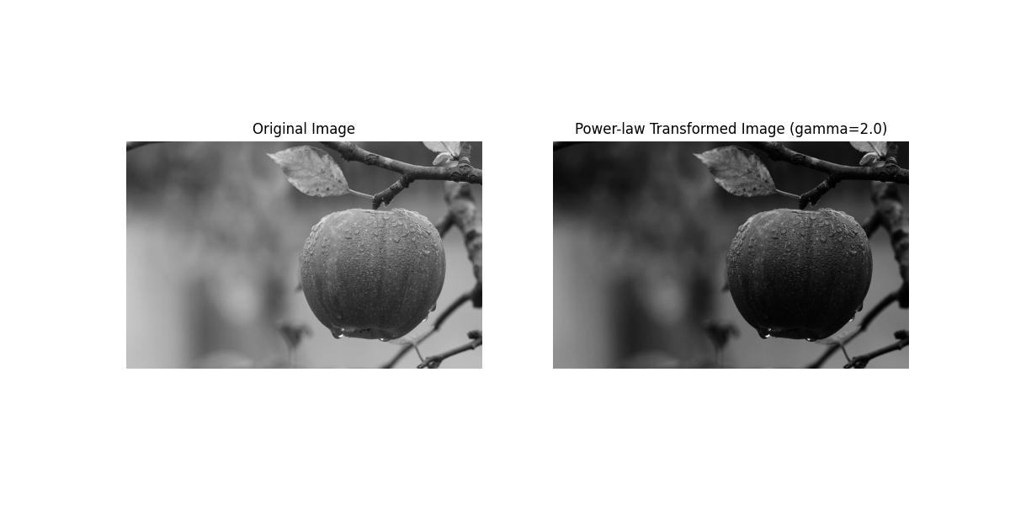Output:

1. Write a Python code for identify the edge of an image using Sobel operator.

import cv2

import numpy as np

import matplotlib.pyplot as plt

def sobel_edge_detection(image_path, output_path):

    image = cv2.imread(image_path, cv2.IMREAD_GRAYSCALE)

    sobel_x = cv2.Sobel(image, cv2.CV_64F, 1, 0, ksize=3)

    sobel_y = cv2.Sobel(image, cv2.CV_64F, 0, 1, ksize=3)

    sobel_magnitude = np.sqrt(sobel_x**2 + sobel_y**2)

    sobel_magnitude = np.uint8(np.absolute(sobel_magnitude))

    cv2.imwrite(output_path, sobel_magnitude)

    print(f"Sobel edge-detected image saved as {output_path}")

    plt.figure(figsize=(12, 6))

    plt.subplot(1, 2, 1)

    plt.imshow(image, cmap='gray')

    plt.title('Original Image')

    plt.axis('off')

    plt.subplot(1, 2, 2)

    plt.imshow(sobel_magnitude, cmap='gray')

    plt.title('Sobel Edge Detected Image')

    plt.axis('off')

    plt.show()

    cv2.imshow('Original Image', image)

    cv2.imshow('Sobel Edge Detected Image', sobel_magnitude)

    cv2.waitKey(0)

    cv2.destroyAllWindows()

input_image_path = 'apple.jpeg'

output_image_path = 'sobel_edge_detected_image.jpg'

sobel_edge_detection(input_image_path, output_image_path)

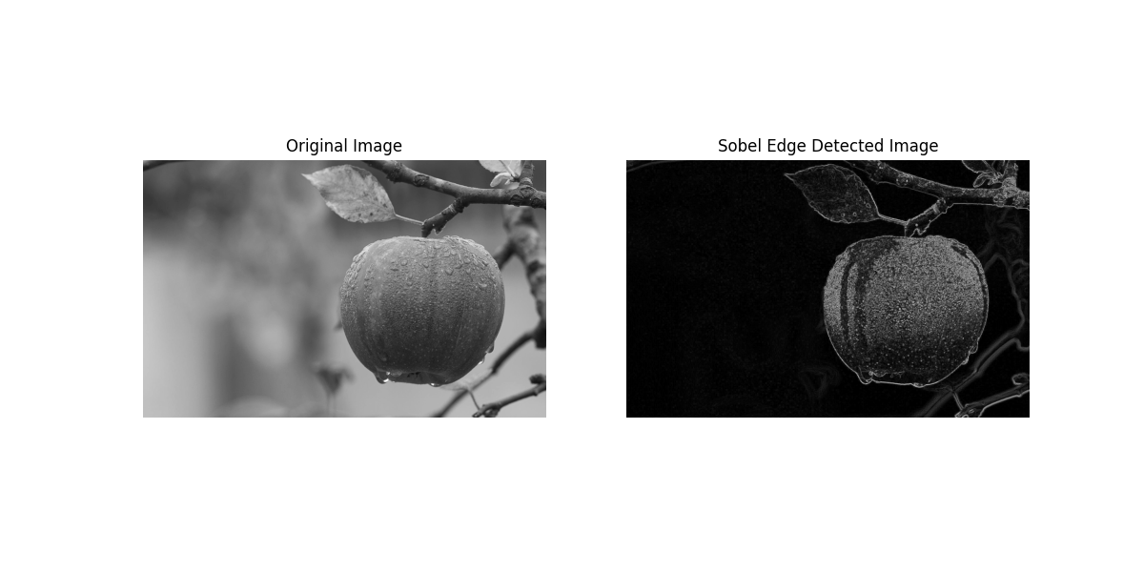Output:

1. Write a Python code for identify edge of an image using Canny Edge Detector.

import cv2

import numpy as np

import matplotlib.pyplot as plt

def canny_edge_detection(image_path, output_path, low_threshold, high_threshold):

    image = cv2.imread(image_path, cv2.IMREAD_GRAYSCALE)

    edges = cv2.Canny(image, low_threshold, high_threshold)

    cv2.imwrite(output_path, edges)

    print(f"Canny edge-detected image saved as {output_path}")

    plt.figure(figsize=(12, 6))

    plt.subplot(1, 2, 1)

    plt.imshow(image, cmap='gray')

    plt.title('Original Image')

    plt.axis('off')

    plt.subplot(1, 2, 2)

    plt.imshow(edges, cmap='gray')

    plt.title('Canny Edge Detected Image')

    plt.axis('off')

    plt.show()

    cv2.imshow('Original Image', image)

    cv2.imshow('Canny Edge Detected Image', edges)

    cv2.waitKey(0)

    cv2.destroyAllWindows()

input_image_path = 'apple.jpeg'

output_image_path = 'canny_edge_detected_image.jpg'

low_threshold = 50  # Lower bound for the hysteresis thresholding

high_threshold = 150  # Upper bound for the hysteresis thresholding

canny_edge_detection(input_image_path, output_image_path, low_threshold, high_threshold)

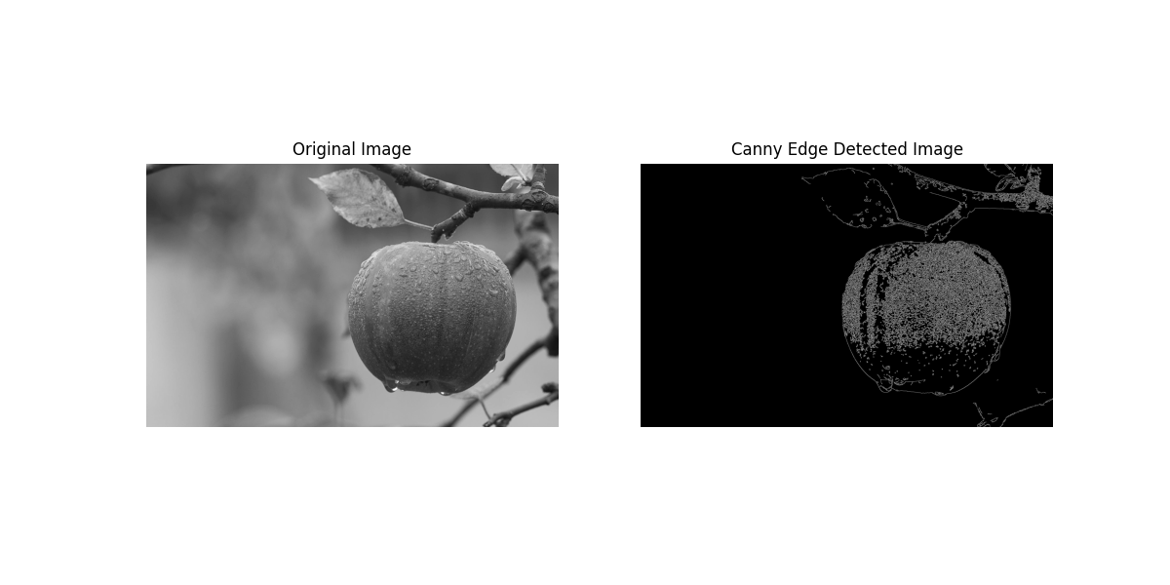Output:

1. Write a Python code for identify edge of an image using Roberts Edge Detection Operator.

import cv2

import numpy as np

import matplotlib.pyplot as plt

def roberts_cross_edge_detection(image_path, output_path):

    image = cv2.imread(image_path, cv2.IMREAD_GRAYSCALE)

    kernel_x = np.array([[1, 0], [0, -1]], dtype=int)

    kernel_y = np.array([[0, 1], [-1, 0]], dtype=int)

    roberts_x = cv2.filter2D(image, cv2.CV_64F, kernel_x)

    roberts_y = cv2.filter2D(image, cv2.CV_64F, kernel_y)

    magnitude = np.sqrt(roberts_x**2 + roberts_y**2)

    magnitude = np.uint8(np.absolute(magnitude))

    cv2.imwrite(output_path, magnitude)

    print(f"Roberts edge-detected image saved as {output_path}")

    plt.figure(figsize=(12, 6))

    plt.subplot(1, 2, 1)

    plt.imshow(image, cmap='gray')

    plt.title('Original Image')

    plt.axis('off')

    plt.subplot(1, 2, 2)

    plt.imshow(magnitude, cmap='gray')

    plt.title('Roberts Edge Detected Image')

    plt.axis('off')

    plt.show()

    cv2.imshow('Original Image', image)

    cv2.imshow('Roberts Edge Detected Image', magnitude)

    cv2.waitKey(0)

    cv2.destroyAllWindows()

input_image_path = 'forest.png'

output_image_path = 'roberts_edge_detected_image.jpg'

roberts_cross_edge_detection(input_image_path, output_image_path)

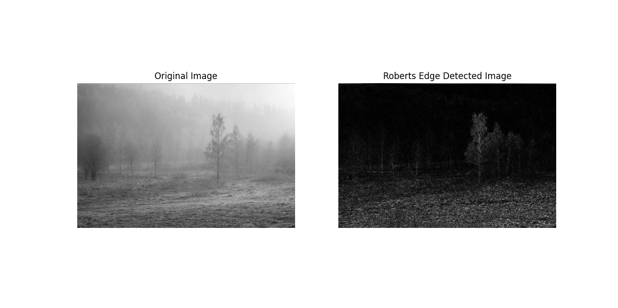Output: